Made Gde Krisna Wangsa / 5027201047
Soal 15

Masukan .pcap file di Wireshark
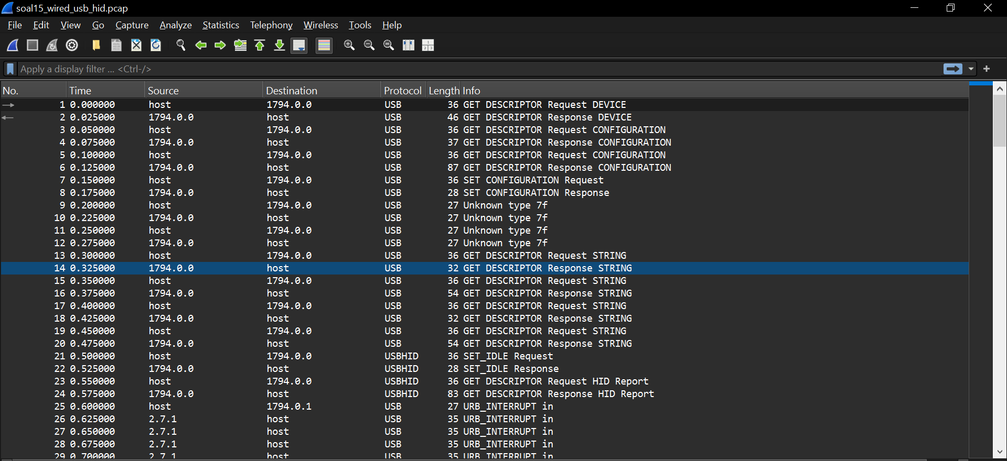

Kemudian cek device descriptor dibawah kiri untuk mencari id
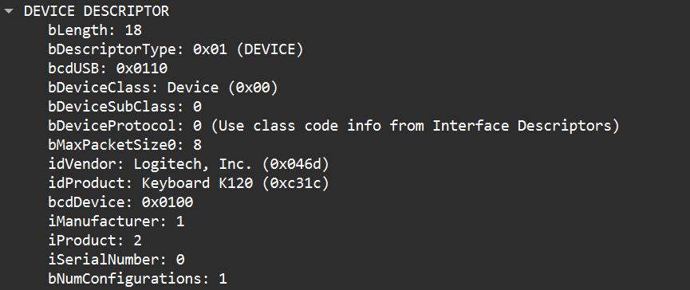

idVendor (Vendor ID): 0x046d (Logitech, Inc.)
idProduct (Product ID): 0xc31c (Keyboard K120)
Source: 2.7.1

Translate: semua key ada didalam protocol ini, isi key ada didalam leftover capture data
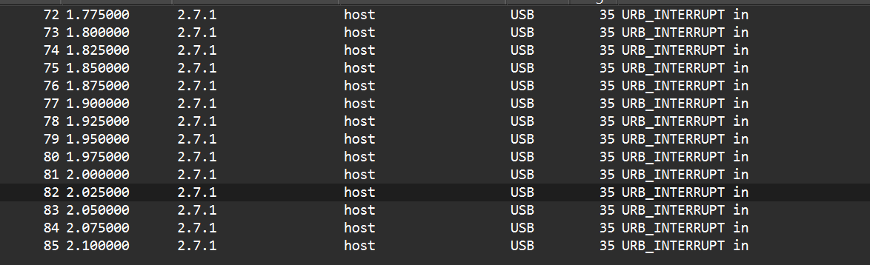

Isi capture data:
Leftover Capture Data: 02001a0000000000 Leftover Capture Data: 00000c0000000000 Leftover Capture Data: 0000150000000000 Leftover Capture Data: 0000080000000000 Leftover Capture Data: 0000070000000000 Leftover Capture Data: 02002d0000000000 Leftover Capture Data: 0200130000000000 Leftover Capture Data: 0000150000000000 Leftover Capture Data: 0000120000000000 Leftover Capture Data: 0000170000000000 Leftover Capture Data: 0000120000000000 Leftover Capture Data: 0000060000000000 Leftover Capture Data: 0000120000000000 Leftover Capture Data: 00000f0000000000
Leftover Capture Data: 02002d0000000000 Leftover Capture Data: 0000240000000000 Leftover Capture Data: 02002d0000000000 Leftover Capture Data: 00000c0000000000 Leftover Capture Data: 0000160000000000 Leftover Capture Data: 02002d0000000000 Leftover Capture Data: 0000040000000000 Leftover Capture Data: 00000f0000000000
Leftover Capture Data: 00000c0000000000 Leftover Capture Data: 0000190000000000 Leftover Capture Data: 0000080000000000 Leftover Capture Data: 02002d0000000000 Leftover Capture Data: 00001f0000000000 Leftover Capture Data: 0000270000000000
Leftover Capture Data: 00001f0000000000 Leftover Capture Data: 0000230000000000

.pcap file ini dapat di export sebagai plaintext file yang kemudian di translate dari Keycode menjadi plaintext dengan translator sendiri.

Jika di translate USB HID Keycode Decoder menjadi plaintext: Wired_Protocol_7_is_alive_2026

Bukti:
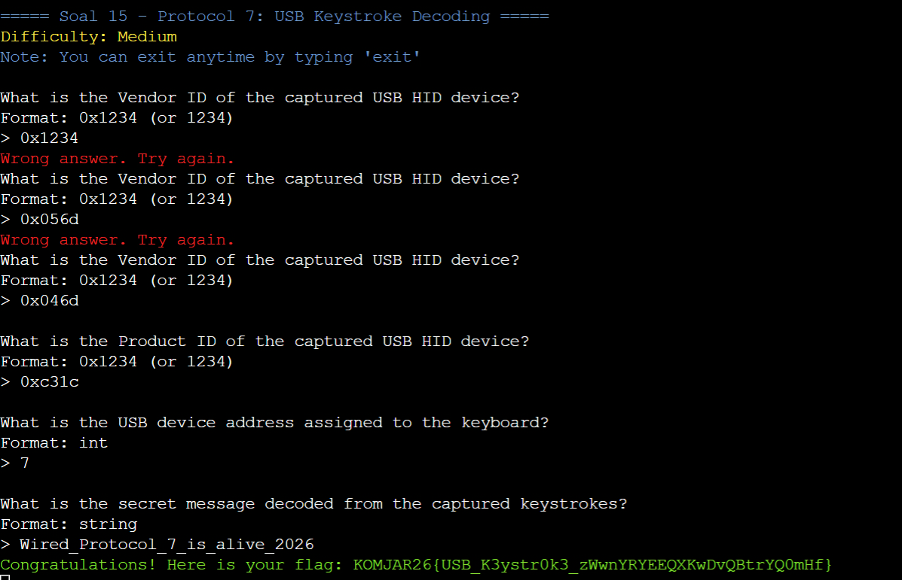

SOAL 16:
Filter wireshark dengan “ftp || ftp-data” dan kemudian cari knight untuk mencari identitas penyerang
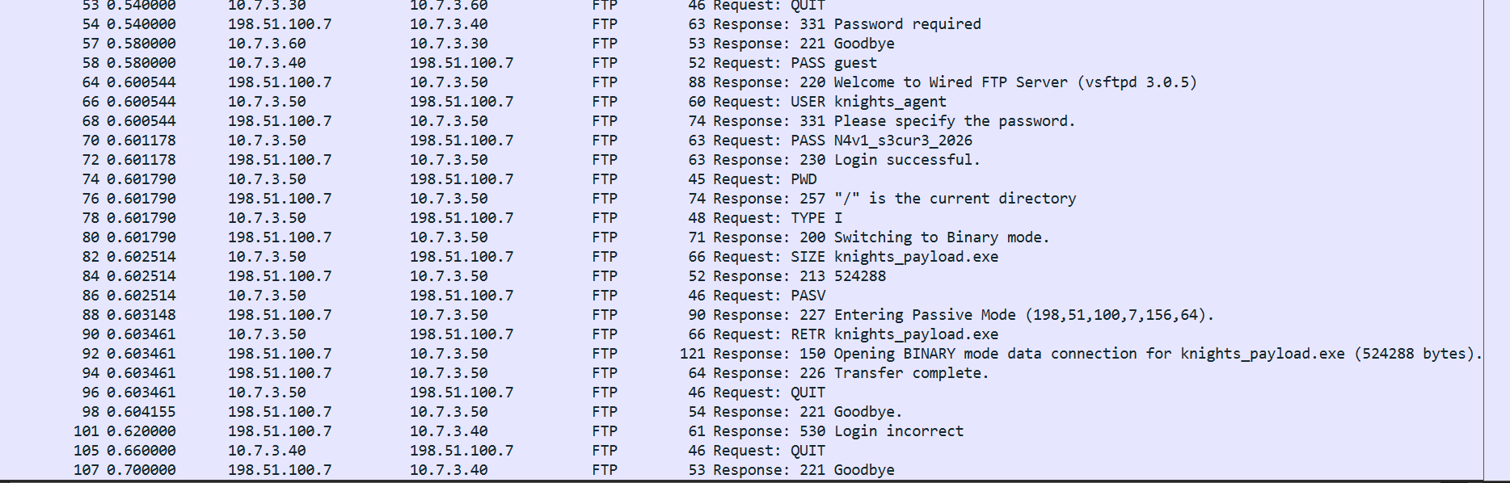

IP Server: 198.51.100.7
Banner: vsftpd 3.0.5
Username: knights_agent
Password: N4v1_s3cur3_2026
File Size: 524288

Bukti di dalam website:
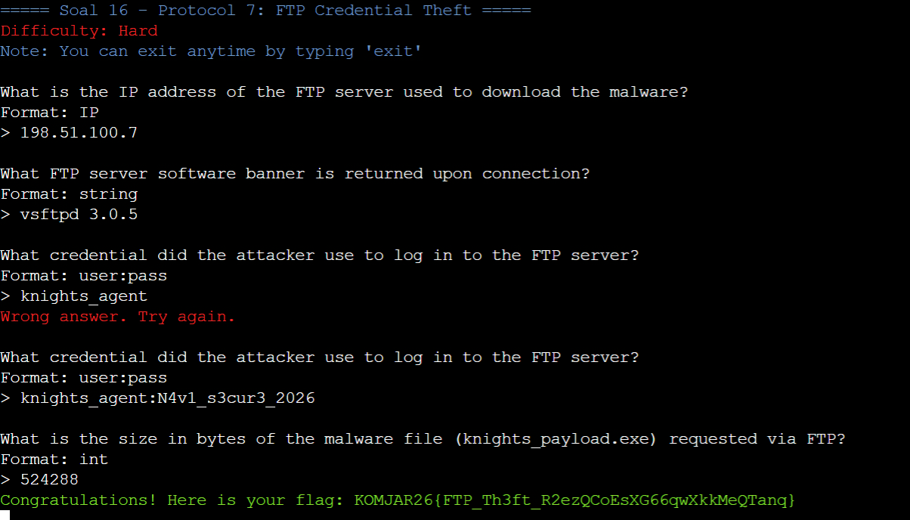

Soal 17

Mencari di wireshark “http” yang memanggil “GET”
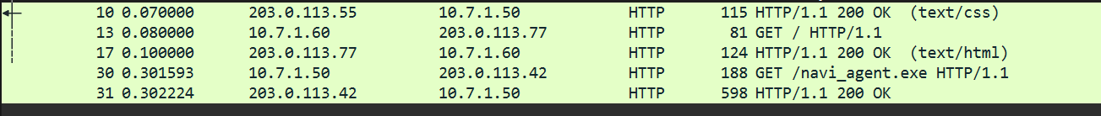

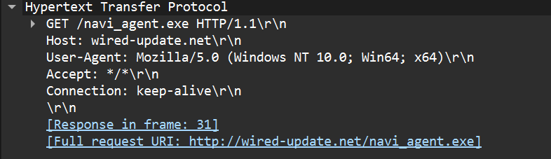
Domain Name / Host: wired-update.net
Attacker IP Address: 203.0.113.42
Malware Executable Filename: navi_agent.exe
HTTP Status Code: 200

Bukti:
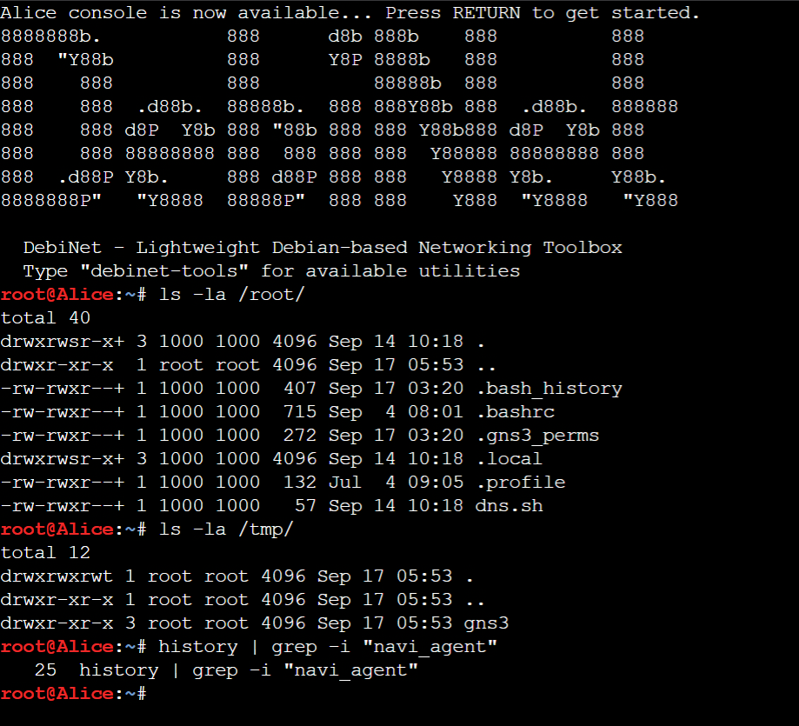

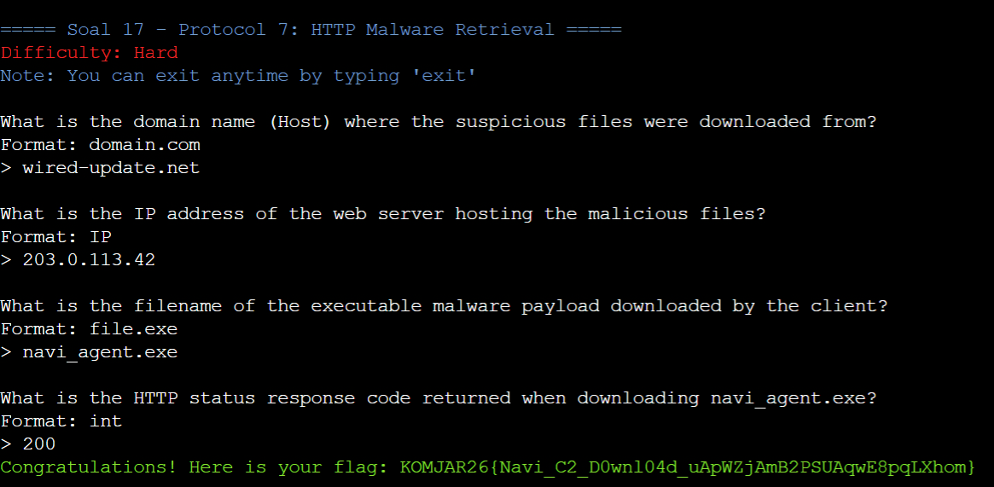

Soal 18

Mencari dengan filter “smb2” di wireshark
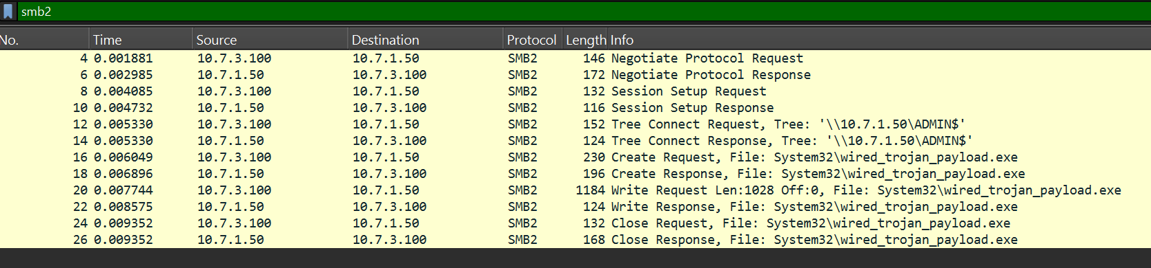

Source / Attacker IP (Pengirim): 10.7.3.100
Destination / Victim IP (Penerima): 10.7.1.50
Destination Folder / Target Path: ADMIN$ dan System32
Malware Filename: wired_trojan_payload.exe

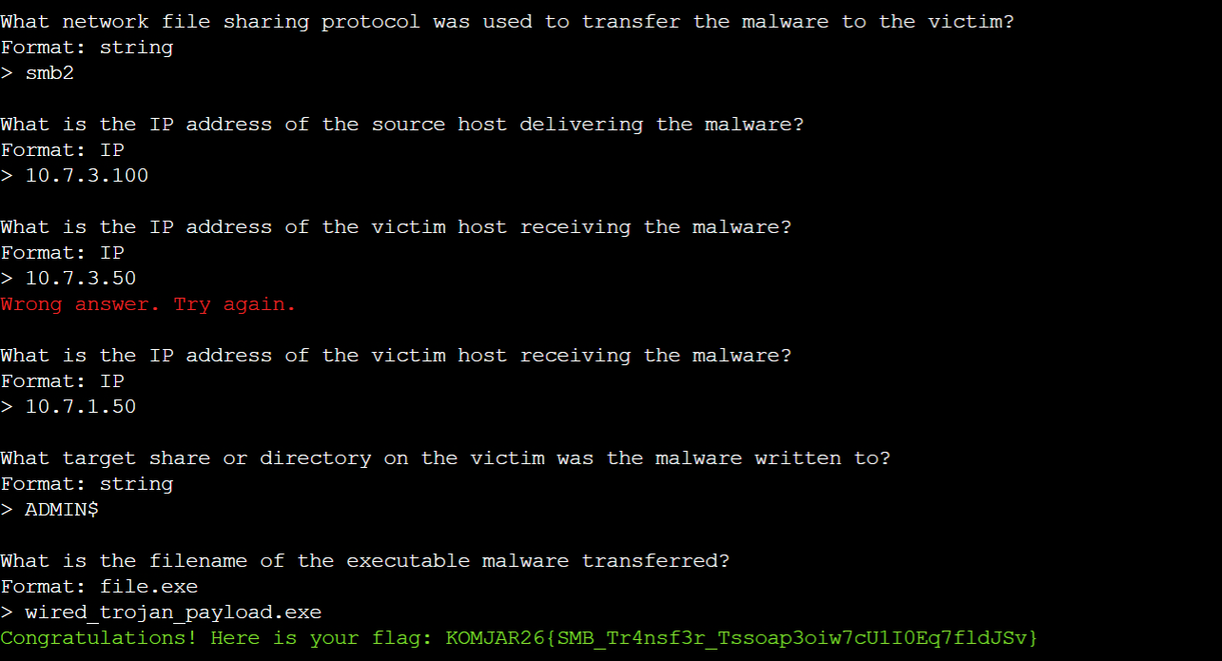

Soal 19

Dengan Wireshark dan filter smtp dan cari didalam TCP Stream yang leak password dan memberi malware.
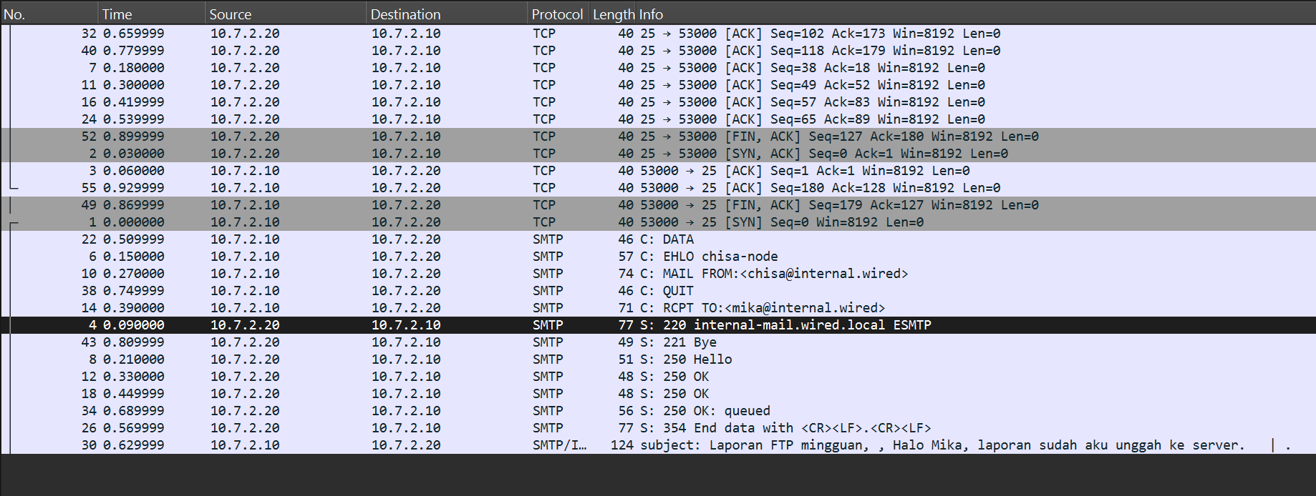
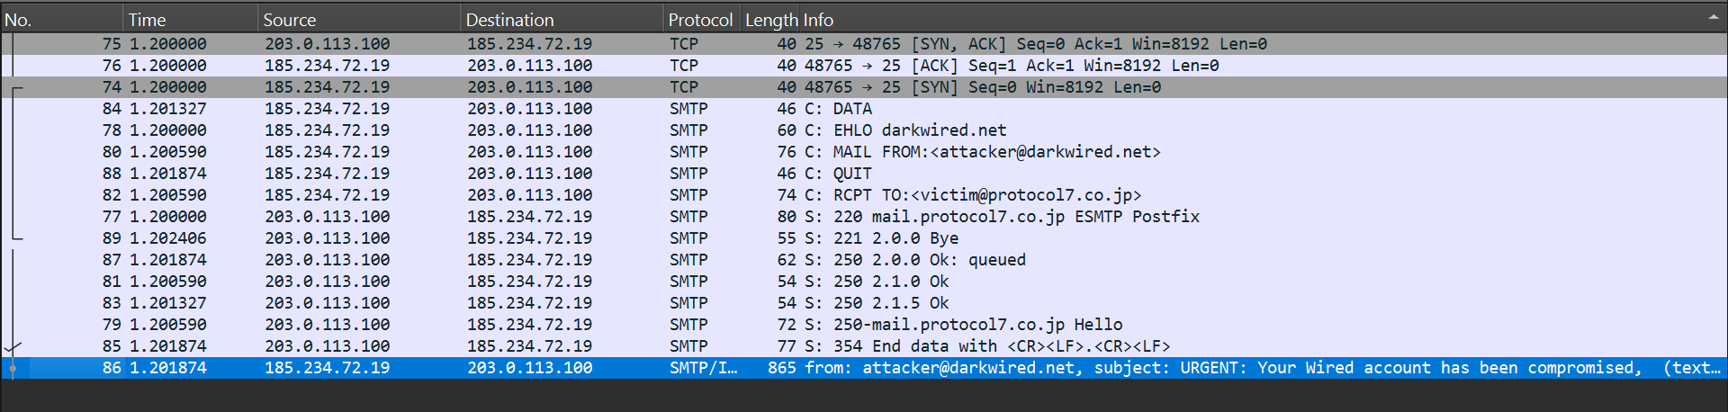

Isi follow tcp stream attacker:
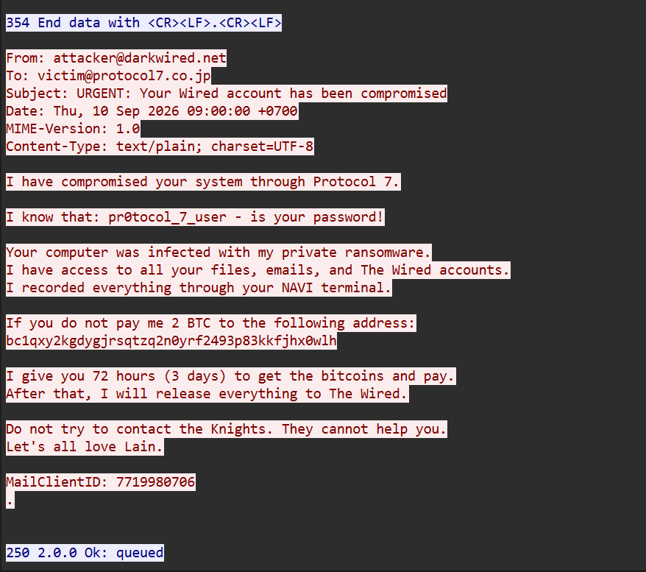
Victim Email Address:
victim@protocol7.co.jp
Leaked Password:
pr0tocol_7_user
Malware Type:
ransomware (atau private ransomware)
Deadline (in days):
3
MailClientID:
7719980706

Bukti:
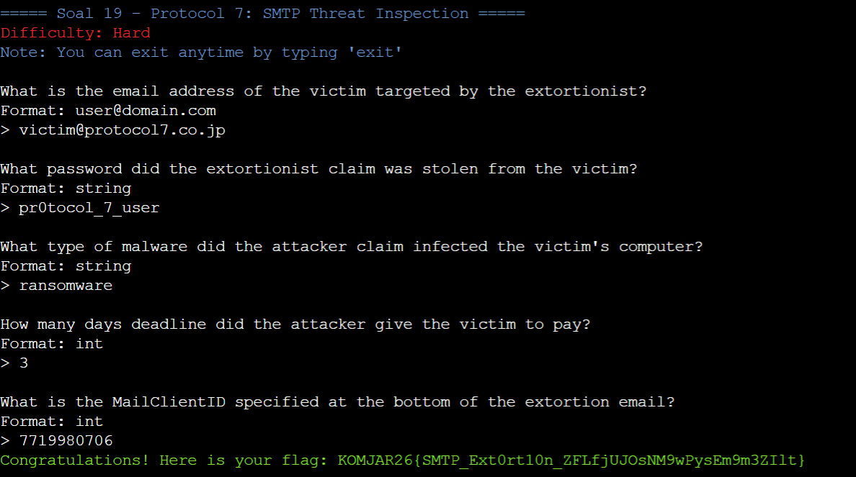

Soal 20

Untuk membaca dekripsi dimulai dengan memasukan keylogger.txt kedalam pre-master-secret log file
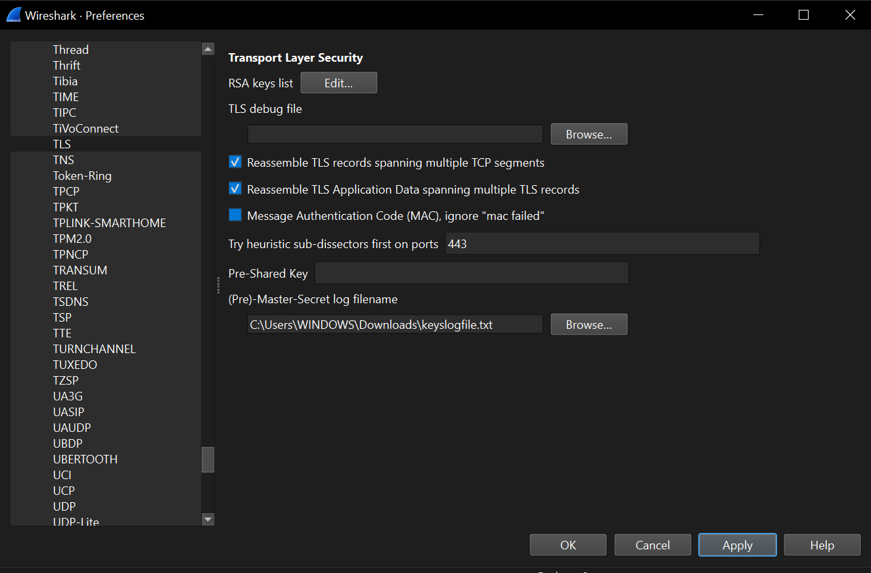

Nanti akan terlihat seperti ini

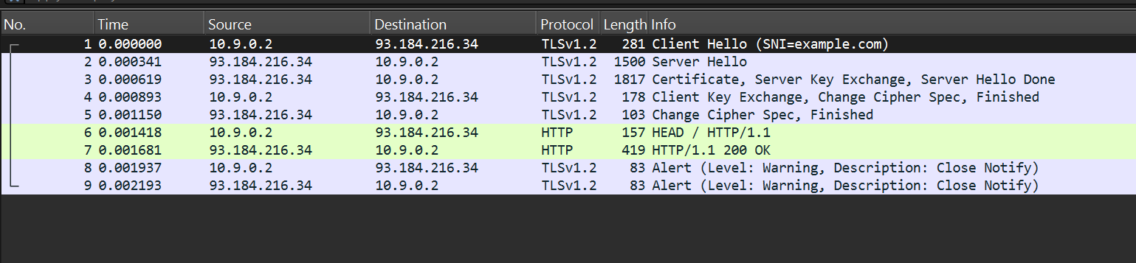
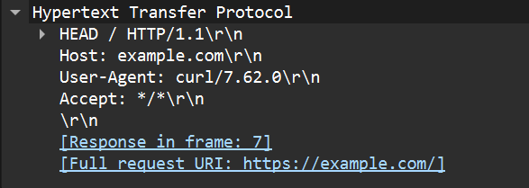

TLS Protocol Version: TLSv1.2
Server Name Indication (SNI) / Host: example.com
Attacker IP: 93.184.216.34
User-Agent: curl/7.62.0
HTTP Request Method: HEAD
HTTP Request Path: /

Bukti:
